Title (Times New Roman, Bold and Font Size: 16)
Author name (put * after the name of corresponding author) (Times New Roman, Bold and Font Size: 10)
Author affiliation (Times New Roman, Font Size: 8.5)
Author email id (Times New Roman, Font Size: 10)

Abstract (Times New Roman, Bold and Font Size: 10)

Keywords: (5-6) (Times New Roman, Bold and Font Size: 10)

  - Introduction (Times New Roman, Bold and Font Size: 12)
Currently under development are arrhythmia monitors for ambulatory patients which analyze the ECG in real time [1] - [3].Software QRS detectors typically include one or more of three different types of processing steps: linear digital filtering, nonlinear transformation, and decision rule algorithms [4]. (Body text:-Times New Roman, Font Size: 10)

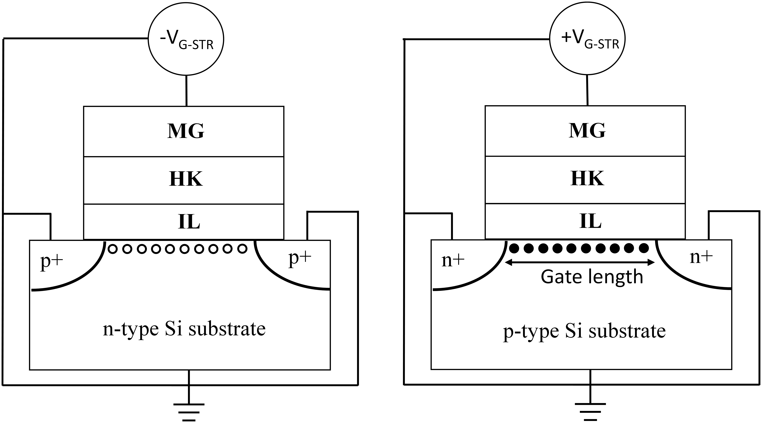
Fig.1.1. Fig Caption (Times New Roman, Font Size: 9)
  - Next Heading (Times New Roman, Bold and Font Size: 12)
(Body text:-Times New Roman, Font Size: 10)

1.2.1. Sub heading (Times New Roman, Bold, and Font Size: 12)
(Body text:-Times New Roman, Font Size: 10)

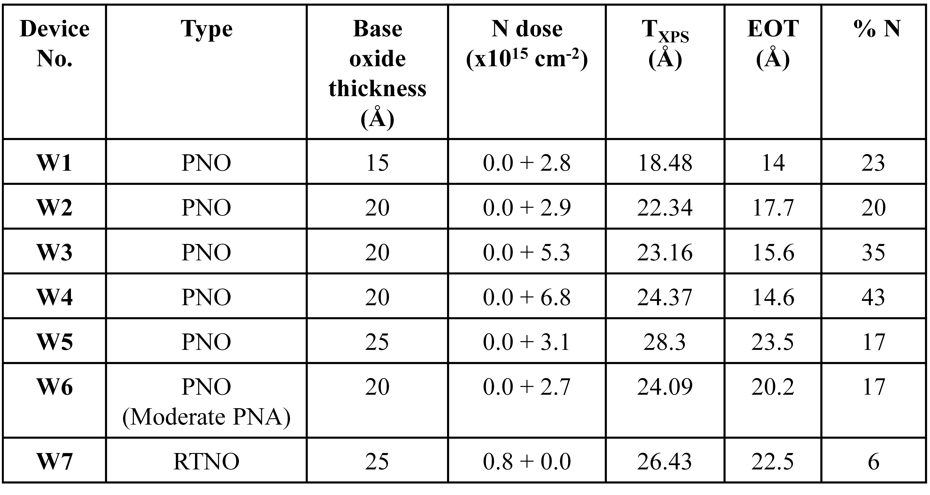
Table 1.1. Table caption. (Times New Roman, Font Size: 9)

1.7. Summary/Conclusion (Times New Roman, Bold, Font Size: 12)
(Body text:-Times New Roman, Font Size: 10)
References: (Times New Roman, Font Size: 12)
[1] Thakor N. V., Webster J. G., and Tompkins W. J.: Design, implementation, and evaluation of a microcomputer-based portable arrhythmia monitor. Med. Biol. Eng. Comput., vol. 22, pp. 151-159, (1984).
[2] Mark R. G., Moody G. B., Olson W. H., Peterson, P. S. Schulter S. K., and Walters J. B., Jr.: Real-time ambulatory arrhythmia analysis with a microcomputer. Comput. ardiol., pp. 57-62, (1979).
[3] Patomaki L., Forsti J., Nokso-Koivisto V-M., Jokinen, Y.and Lansimies E.: On line recording and analysis of the ECG in ambulatory patients. Comput. Cardiol., pp. 173-175, (1981).
[4] Pahlm 0. and Sornmo L.: Software QRS detection in ambulatory monitoring-A review. Med. Biol. Eng. Comput., vol. 22, pp. 289-297, (1984).

(Reference Text: Calibri, Font Size: 10)

Guideline for Reference Citations in Text
Reference numbers in square brackets with sequential by citation [1]-[3], [4] etc, (Please refer the sequential way it is cited in Introduction and same numbered in Reference Sections, i.e. [1], [2], [3], [4] etc.)

Note: For easy template matching, edit the same template/make a copy of this, for your article where you may not need to resize the margin and other details (Cross check your text (Title, Body Text, etc) alignment by putting the cursor upon the desired text of this template)

